**ARTIFICIAL INTELLIGENCE (ETCS-310)**

Assignment-2

Name – Sarthak Bhatia

Roll No – 07714803118

Group – I-4

**MINMAX WITH ALPHA-BETA PRUNING**

* Alpha-beta pruning is a modified version of the minimax algorithm. It is an optimization technique for the minimax algorithm.
* As we have seen in the minimax search algorithm that the number of game states it has to examine are exponential in depth of the tree. Since we cannot eliminate the exponent, but we can cut it to half. Hence there is a technique by which without checking each node of the game tree we can compute the correct minimax decision, and this technique is called **pruning**. This involves two threshold parameter Alpha and beta for future expansion, so it is called **alpha-beta pruning**. It is also called as **Alpha-Beta Algorithm**.
* Alpha-beta pruning can be applied at any depth of a tree, and sometimes it not only prunes the tree leaves but also entire sub-tree.
* The two-parameter can be defined as:
  1. **Alpha:** The best (highest-value) choice we have found so far at any point along the path of Maximiser. The initial value of alpha is **-∞**.
  2. **Beta:** The best (lowest-value) choice we have found so far at any point along the path of Minimizer. The initial value of beta is **+∞**.
* The Alpha-beta pruning to a standard minimax algorithm returns the same move as the standard algorithm does, but it removes all the nodes which are not really affecting the final decision but making algorithm slow. Hence by pruning these nodes, it makes the algorithm fast.
* The main condition which required for alpha-beta pruning is: α>=β.

**Pseudo-code for Alpha-beta Pruning:**

**function** minimax(node, depth, isMaximizingPlayer, alpha, beta):

**if** node is a leaf node :

**return** value of the node

**if** isMaximizingPlayer :

bestVal = -INFINITY

**for each** child node :

value = minimax(node, depth+1, false, alpha, beta)

bestVal = max( bestVal, value)

alpha = max( alpha, bestVal)

**if** beta <= alpha:

**break**

**return** bestVal

**else** :

bestVal = +INFINITY

**for each** child node :

value = minimax(node, depth+1, true, alpha, beta)

bestVal = min( bestVal, value)

beta = min( beta, bestVal)

**if** beta <= alpha:

**break**

**return** bestVal

**// Calling the function for the first time.**

minimax(0, 0, true, -INFINITY, +INFINITY)

**Key points about alpha-beta pruning:**

* The Max player will only update the value of alpha.
* The Min player will only update the value of beta.
* While backtracking the tree, the node values will be passed to upper nodes instead of values of alpha and beta.
* We will only pass the alpha, beta values to the child nodes.

## Working of Alpha-Beta Pruning:

Let's take an example of two-player search tree to understand the working of Alpha-beta pruning

**Step 1:** At the first step the, max player will start first move from node A where α= -∞ and β= +∞, these value of alpha and beta passed down to node B where again α= -∞ and β= +∞, and Node B passes the same value to its child D.

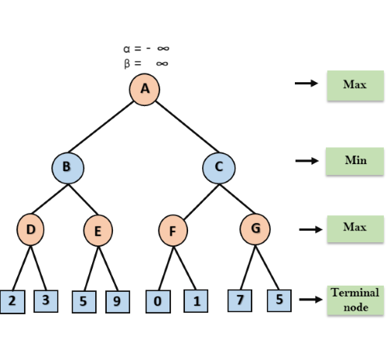

**Step 2:** At Node D, the value of α will be calculated as its turn for Max. The value of α is compared with firstly 2 and then 3, and the max (2, 3) = 3 will be the value of α at node D and node value will also 3.

**Step 3:** Now algorithm backtrack to node B, where the value of β will change as this is a turn of Min, now β= +∞, will compare with the available subsequent nodes value, i.e. min (∞, 3) = 3, hence at node B now α= -∞, and β= 3.

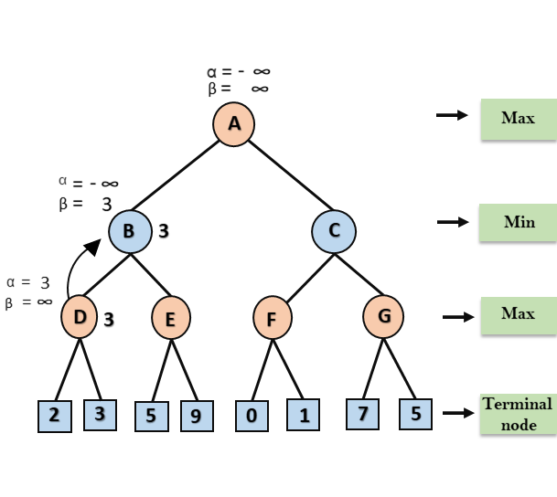

In the next step, algorithm traverse the next successor of Node B which is node E, and the values of α= -∞, and β= 3 will also be passed.

**Step 4:** At node E, Max will take its turn, and the value of alpha will change. The current value of alpha will be compared with 5, so max (-∞, 5) = 5, hence at node E α= 5 and β= 3, where α>=β, so the right successor of E will be pruned, and algorithm will not traverse it, and the value at node E will be 5.

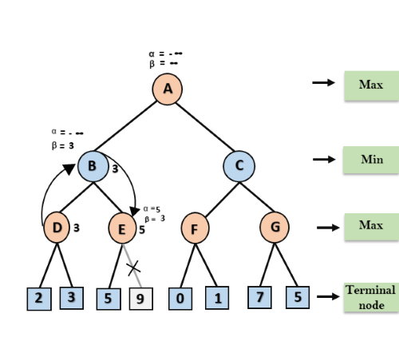

**Step 5:** At next step, algorithm again backtrack the tree, from node B to node A. At node A, the value of alpha will be changed the maximum available value is 3 as max (-∞, 3) = 3, and β= +∞, these two values now pass to right successor of A which is Node C. At node C, α=3 and β= +∞, and the same values will be passed on to node F.

**Step 6:** At node F, again the value of α will be compared with left child which is 0, and max (3,0) = 3, and then compared with right child which is 1, and max (3,1) = 3 still α remains 3, but the node value of F will become 1.

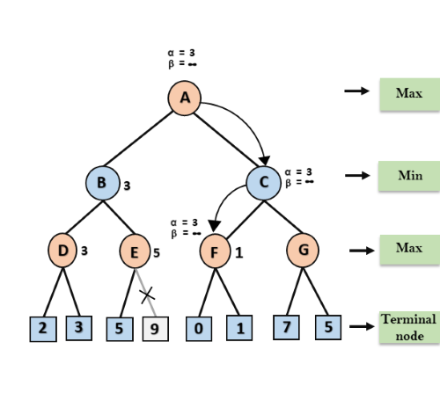

**Step 7:** Node F returns the node value 1 to node C, at C α= 3 and β= +∞, here the value of beta will be changed, it will compare with 1 so min (∞, 1) = 1. Now at C, α=3 and β= 1, and again it satisfies the condition α>=β, so the next child of C which is G will be pruned, and the algorithm will not compute the entire sub-tree G.

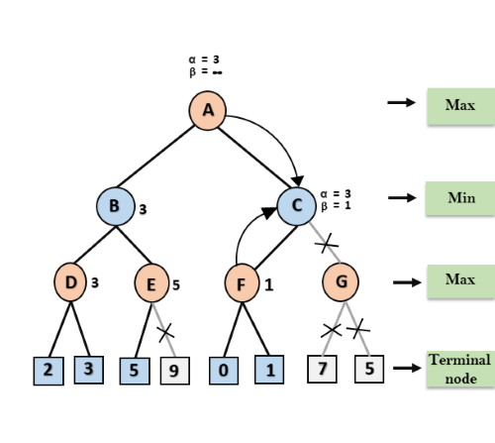

**Step 8:** C now returns the value of 1 to A here the best value for A is max (3, 1) = 3. Following is the final game tree which is the showing the nodes which are computed and nodes which has never computed. Hence the optimal value for the maximiser is 3 for this example.

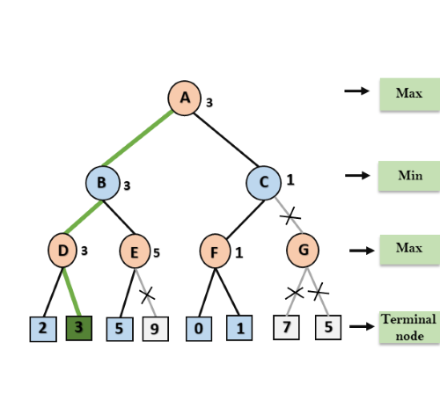

**Move Ordering in Alpha-Beta pruning:**

The effectiveness of alpha-beta pruning is highly dependent on the order in which each node is examined. Move order is an important aspect of alpha-beta pruning.

It can be of two types:

* **Worst ordering:** In some cases, alpha-beta pruning algorithm does not prune any of the leaves of the tree, and works exactly as minimax algorithm. In this case, it also consumes more time because of alpha-beta factors, such a move of pruning is called worst ordering. In this case, the best move occurs on the right side of the tree. The time complexity for such an order is O(bm).
* **Ideal ordering:** The ideal ordering for alpha-beta pruning occurs when lots of pruning happens in the tree, and best moves occur at the left side of the tree. We apply DFS hence it first search left of the tree and go deep twice as minimax algorithm in the same amount of time. Complexity in ideal ordering is O(bm/2).